Configuring **Wireshark** to view MAC level **LTE messages**

1. Go to Edit > Preference (or Ctrl+Shift+P)

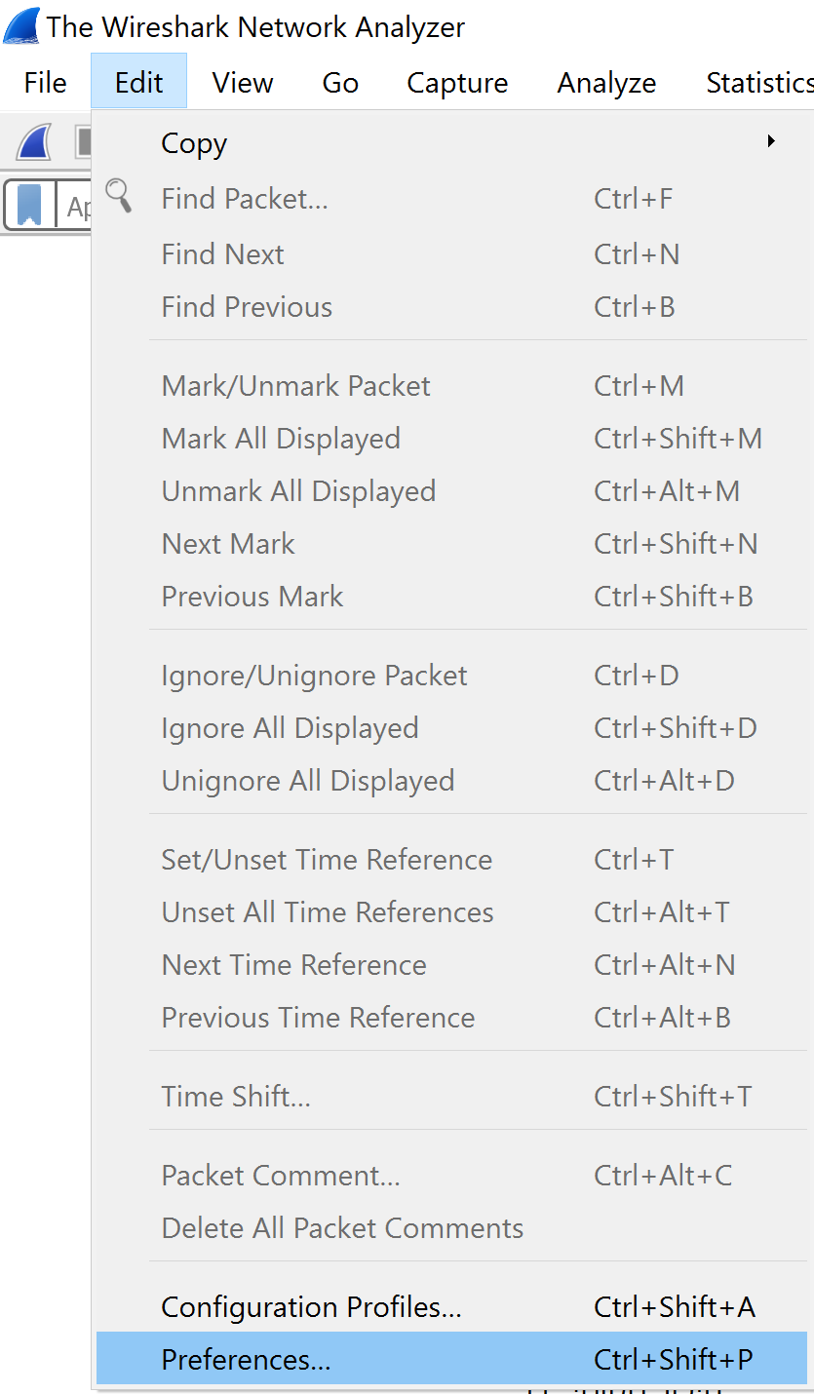

1. Under Protocols, go to DLT_USER and press edit

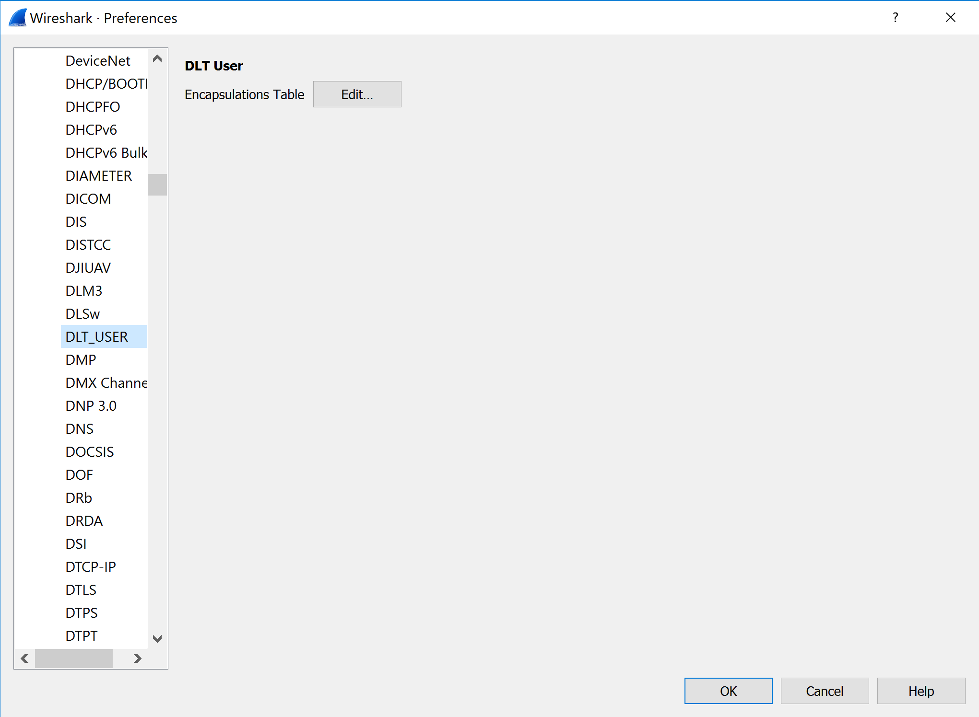

1. Press add (+)

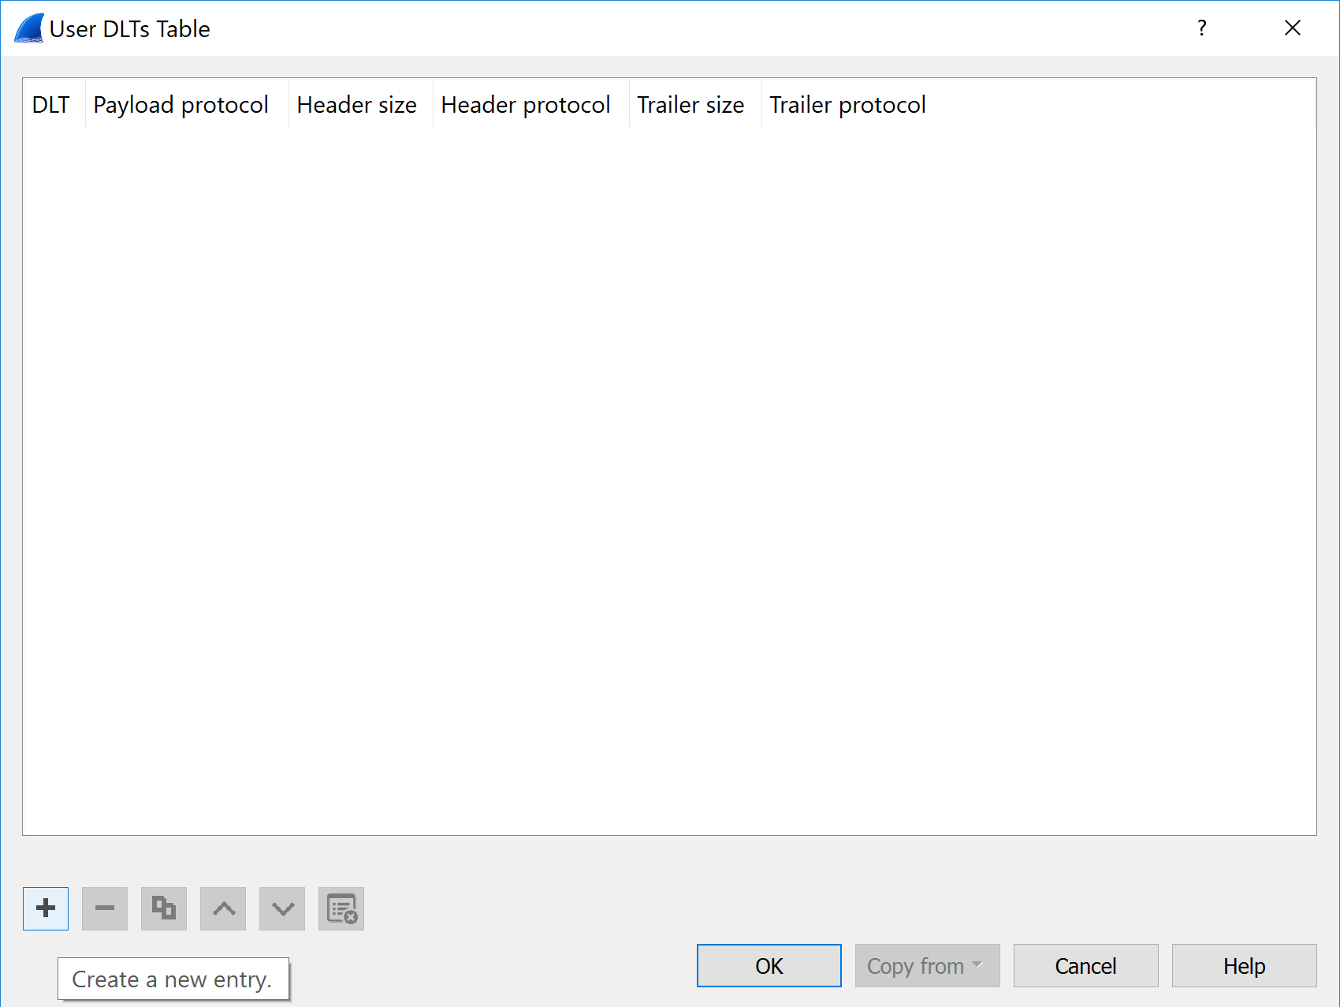

1. Enter the User 0 (DLT=147) and write in the Payload protocol “mac-lte-framed” and then press OK.

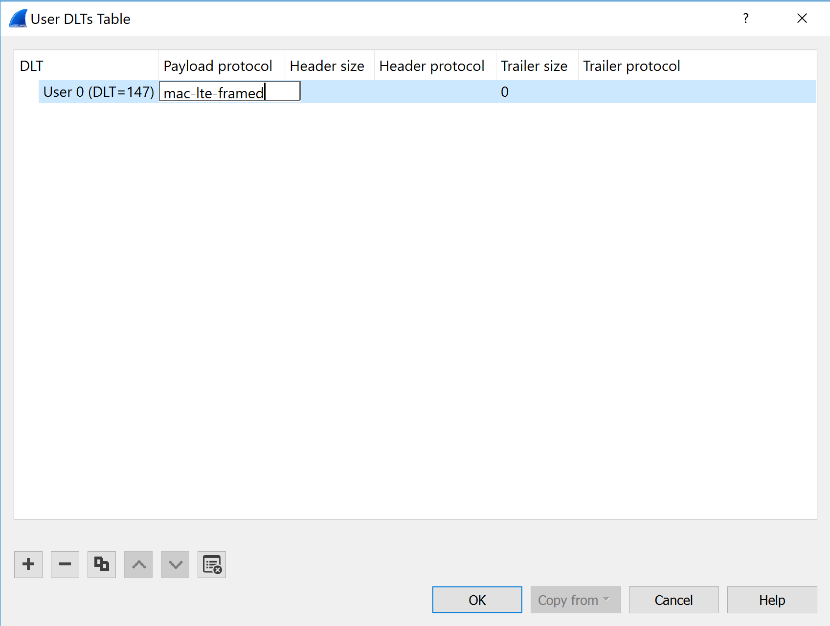

1. Now we are ready to view the LTE pcaps. Good job!